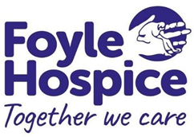
PERSON SPECIFICATION

JOB TITLE: Community Nurse Palliative Care Band 6
(Agenda for Change pay scale)

Please note Foyle Hospice terms and conditions vary from Agenda for
Change.

REPORTS TO: Community Services Manager

RESPONSIBLE TO: Director of Nursing and Clinical Care

 | ESSENTIAL | DESIRABLE | METHOD OF ASSESSMENT
EDUCATION AND QUALIFICATIONS | Level 1 Registered Nurse (Adult) on the NMC Live Register.  An accredited module/course in Palliative Care e.g. European Certificate/CEC module.  Relevant three years post registration experience at Band 5 or above in Cancer, Palliative Care in a health care setting. | Community experience.  Advanced communication skills training. | Application Form  Application Form  Application Form
KNOWLEDGE AND SKILLS | Clinical care of patients with palliative care needs.  Demonstrate knowledge of clinical governance, research and audit. |  | Interview
EXPERIENCE | Evidence of dealing with complex and difficult emotional situations. |  | Interview
PERSONAL QUALITIES | Teaching and facilitation skills.  Evidence of effective communication and multi-professional working. |  | Interview
OTHER | Car driver with full up to date driving licence.  Weekend working and bank holidays will be required. |  | Application Form  Interview  Interview  Interview

Where appropriate, reasonable adjustments to these criteria will be considered to accommodate personal circumstances such as disabilities.
April 2024

