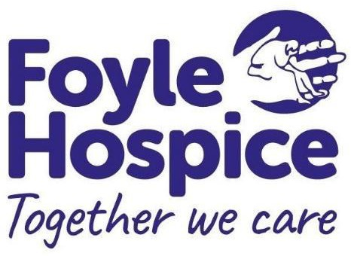
JOB DESCRIPTION

Job Title: Communications Officer

Responsible to: Director of Income Generation and Communications

Salary: Band 4 (£23,949 to £26,282 pro rata)

Hours: 30 hours per week/includes out of hours as required

Location: Derry/Londonderry

Overall Purpose
To assist in the development and delivery of internal and external Public Relations, Communications and Marketing activities, to publicise Foyle Hospice, raising awareness of the organisation’s clinical work, encourage support and uptake of services, community initiatives, volunteering and fundraising activities including opportunities for corporate and social partnerships.

Key responsibilities include:

Strategic Priorities
- Support the Trustees, Chief Executive and Senior Management Team to ensure that the profile of the hospice is increased and communication opportunities are maximised.

- Represent Foyle Hospice on groups, networks and at events in Northern Ireland

Operational Responsibilities
PR, Communications & Marketing

- Copy writing, editing and proofreading for various online and offline channels (including press, publications, marketing materials, and website) for various internal and external audiences (including corporate, clinical, and fundraising purposes).

- Raise awareness of all charity, trading company and clinical service activity through writing and creating press releases and media interviews for staff, volunteers, patients and families as appropriate and securing reasonable media coverage.

- Contribute to supporter newsletters and publications when required, liaising with relevant staff and external suppliers to ensure deadlines are met.

- Develop communications and marketing activities and medium ensuring all messages / content is up to date, accurate and appropriate at all times.

- Liaise with wider hospice staff and volunteers, patients and families as necessary to gather and write news stories or other content, managing relationships in an appropriate manner.

- Develop and write case studies and develop new systems for showcasing stories maintaining an up-to-date library of case studies.

- Conduct regular communication audits: e.g. materials, online, internal notice boards and signage to ensure that content and branding is current and consistent with the agreed communications strategy.

- Attend and represent the hospice at internal and external events as required.

- Liaise with other internal departments, in order to advise and develop plans or identify opportunities which raise awareness of Foyle Hospice and its cause.

Personal Development
- Maintain high professional standards and keep abreast of relevant issues and continue own personal and professional development. Foyle Hospice will provide relevant education and development opportunities where it is deemed appropriate.

Monitoring, Evaluation and Management Reporting
- Ensure effective records management (manual and computerized) are maintained accurately and are up-to-date in line with legislation and GDPR to maintain confidentiality and security.

Quality and Safety
- Adhere to quality assurance standards and codes of practice in line with changing requirements, legislative compliance and best practice in relation to the activities under your remit.

- Ensure the efficient and effective use of all our resources (staff, financial and physical).
- Adhere to all organisational policies and procedures.

- Manage your own wellbeing and support interventions for employees in line with organisational need.

- Ensure adherence to all Health and Safety Regulations applicable to the working environment and adhere to same.

Other
Carry out such other duties as required as are consistent with the mission of the organisation and overall purpose of the job.

Access NI Disclosure – Foyle Hospice operates in line with the Access NI Code of Practice. Further details can be obtained from www.accessni.gov.uk.
It should be noted that some posts fall within the definition of ‘Regulated Activity’. Further information on Regulated Activity can be obtained on request. Any post falling within the definition of Regulated Activity will be subject to an Access NI Enhanced Disclosure check with Barred list check.

This job description reflects current aspects of the post and applicants must be aware that the hospice is constantly changing and developing its services. This may mean changes in the role and
the successful applicant will be one who demonstrates a flexible attitude and willingness to embrace change in the interests of the service.

