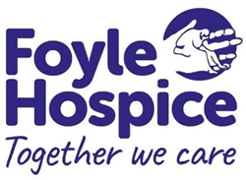 | Foyle Hospice  Person Specification

Job Title: Cleaner (Band 2)
Criteria | Essential | Desirable | Method of Assessment
Qualifications /  Education /  Training | Good standard of Education |  | Application form
Knowledge and Skills | Excellent communication and interpersonal skills.  Excellent organisational skills |  | Application form and interview
Experience | A minimum of six months experience cleaning in a hospital or nursing home |  | Application form and interview
Personal requirements | Self-motivated with the ability to work independently.  Ability to work effectively within a team setting.  High personal standards  Able to plan, manage and prioritise workload  Able to work under pressure |  | Application form and Interview
Other requirements | Flexible attitude to work duties and hours of work |  | Application form  Interview

Where appropriate, reasonable adjustments to these criteria will be considered to accommodate personal circumstances such as disabilities.

